Instructions for Guardians on Filling Out the Application for First Grade Foreign Language and Religion Subject Found in Wilma

The guardian must fill out an application in Wilma for the upcoming first grader regarding the foreign language and religious studies starting in the first grade. In the application, the guardian indicates which foreign language the student would like to study. If the student's religious affiliation in the population register is other than the Evangelical Lutheran Church, the guardian also selects which religious studies the student will participate in. You can explore the options for foreign languages and religious studies on our website.
Application Content and Filling Instructions
- At the beginning of the application, general instructions for using the form and the student's basic information are displayed.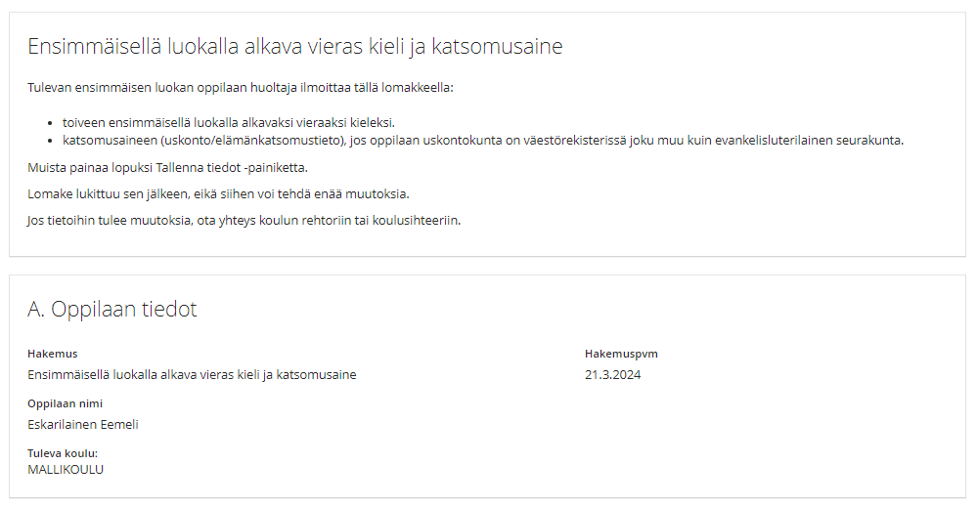

- At the beginning of the section regarding the selection of a foreign language, the language options offered at the student's school are listed. It is mandatory to choose a preferred language and an alternative choice. The guardian can also fill in a second alternative choice. You can explore the languages offered in basic education in Tampere here.
Note! The selection lists show all language options available in Tampere. Remember to choose a language that is offered at your own school from the list.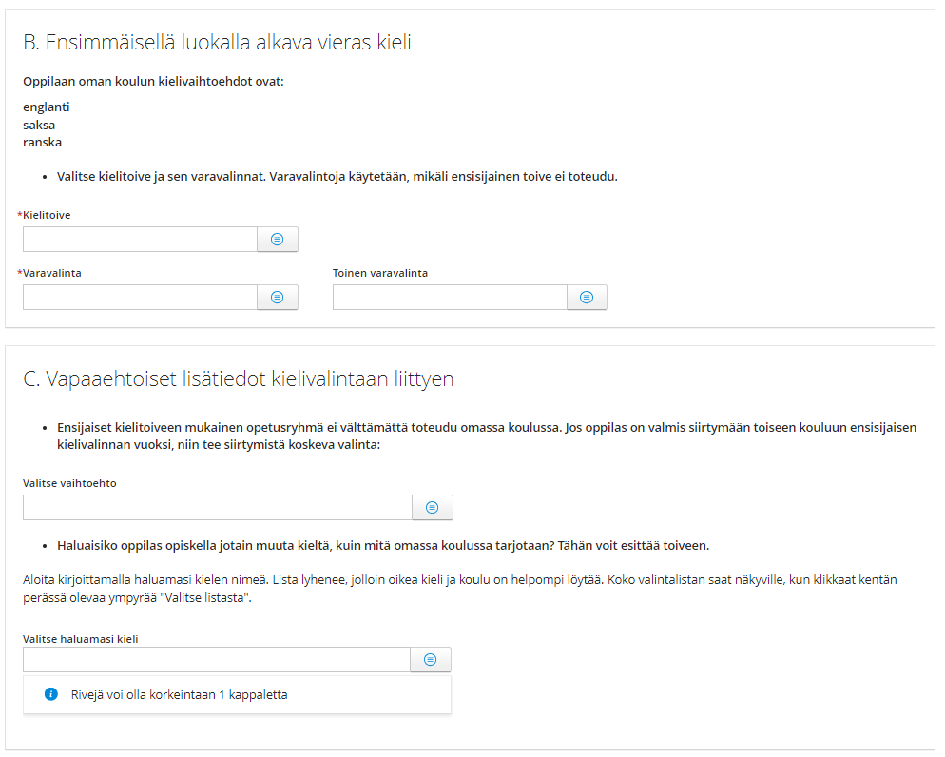

- The next section contains optional additional questions related to the language selection. Fill in these fields only if the student is potentially willing to transfer to another school due to the language choice. This applies in situations where a teaching group for the desired language is not formed at the student's school or the desired language is not an option at the student's school.
- The section regarding the selection of religious studies or ethics. At the beginning of the section, instructions for making the selection are briefly provided. The available options depend on the student's religious affiliation as recorded in the population register. The information from the population register is displayed on the form.
Note! Students who belong to the Evangelical Lutheran Church participate in Evangelical Lutheran religious education. Therefore, no selection is needed in this case.
If the student's religious affiliation is different, the guardian must select. All options are visible in the selection list, but the choice must be made according to the instructions.
.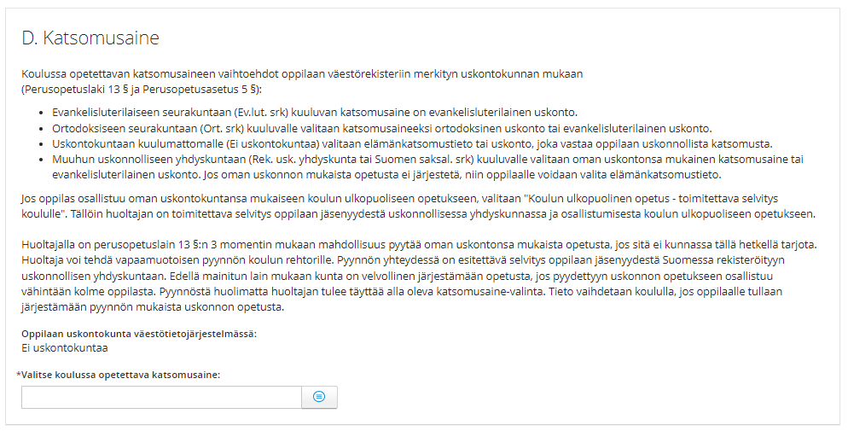

- Section E of the form provides the option to give consent for electronic communication. The child's guardians must agree together on the choices made.

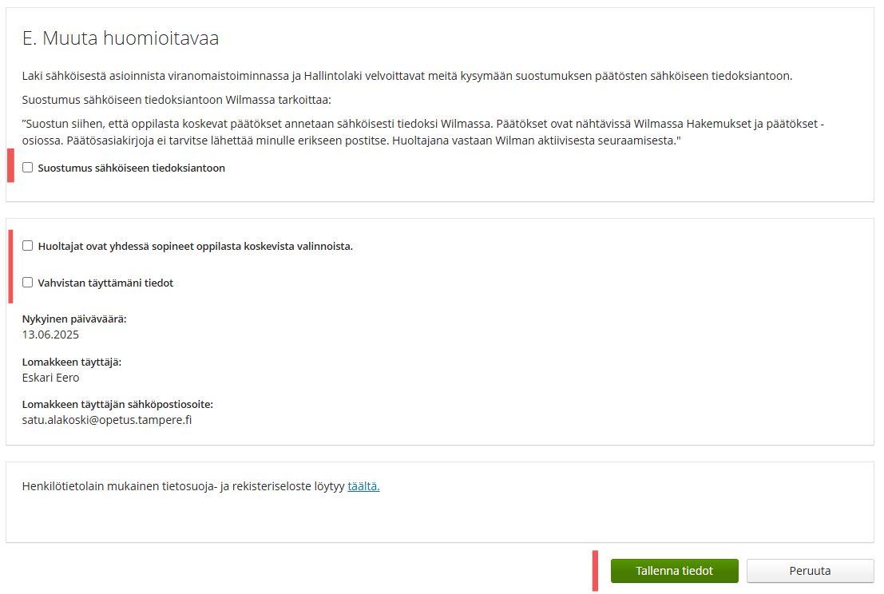
Check the box 'Vahvistan täyttämäni tiedot' (I confirm the information I have provided) and click 'Tallenna tiedot' (Save information).

