Instructions for using the Nuorisopassi
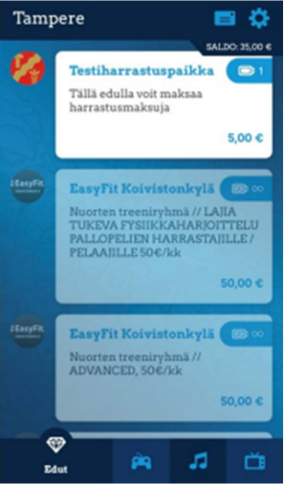

- Select the hobby that interests you in the home page view.
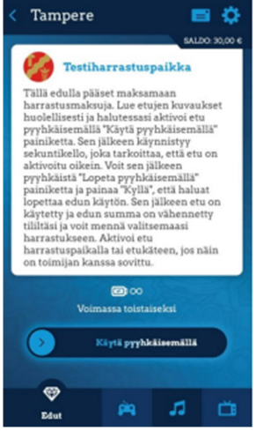
- Read the description to find out more about the hobby and the hobby. If you are interested in a hobby, arrive at the hobby, and activate the advantage by swiping right on the Use advantage button by swiping.
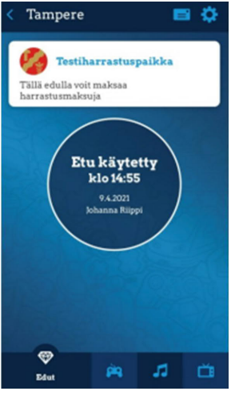

- A clock will appear on the screen, indicating that the benefit has been activated. The amount has now been deducted from your Nuorisopassi account and you can go to the activity of your choice.

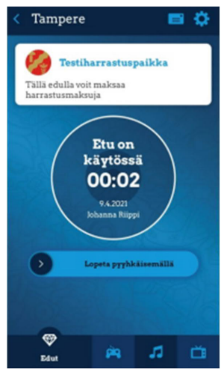

- You can stop using the benefit by swiping right on the Stop swiping button.
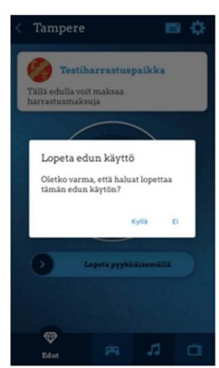

- Then select Yes and the benefit will expire.

